Lab 2：
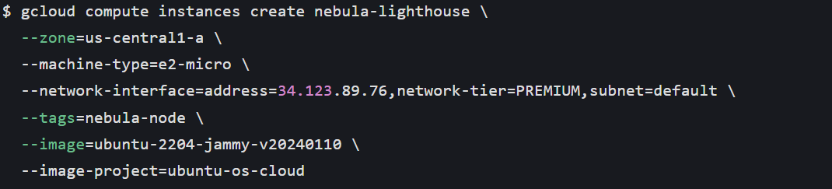
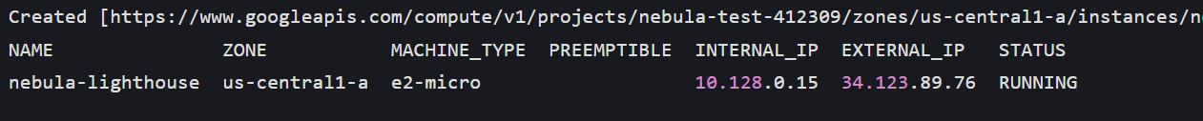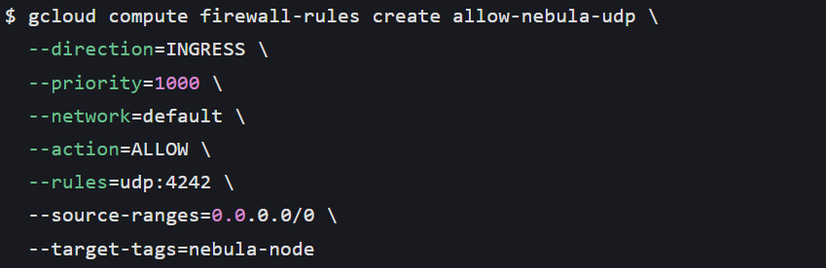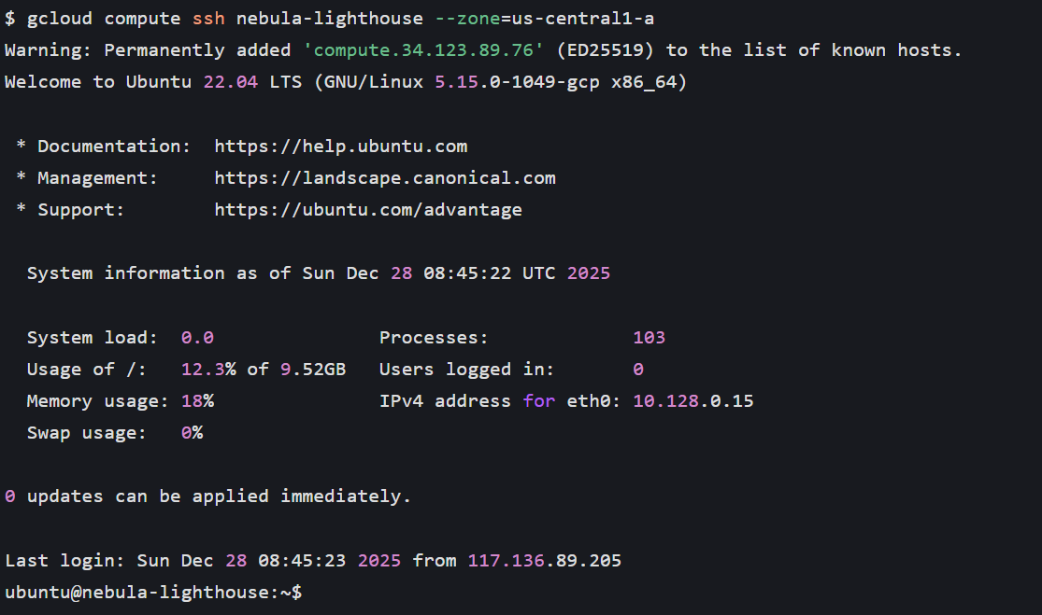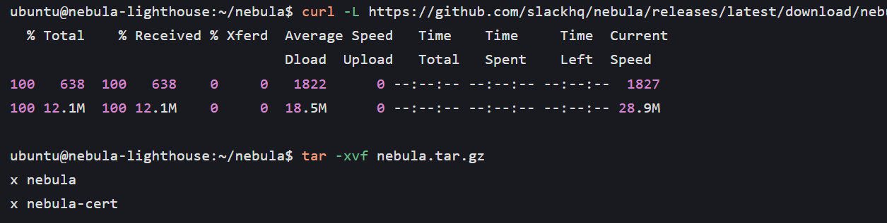
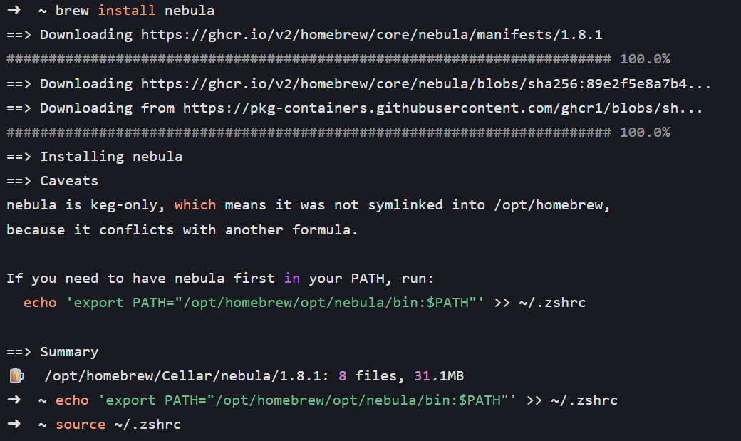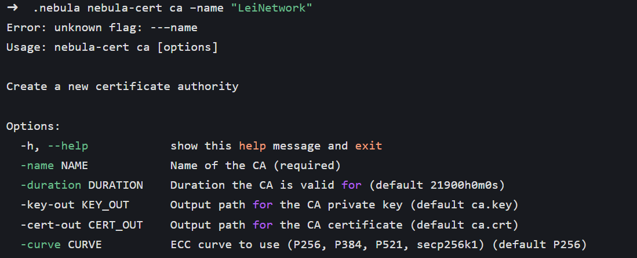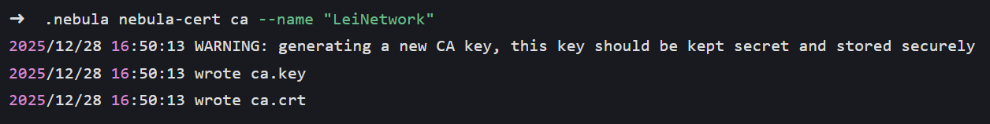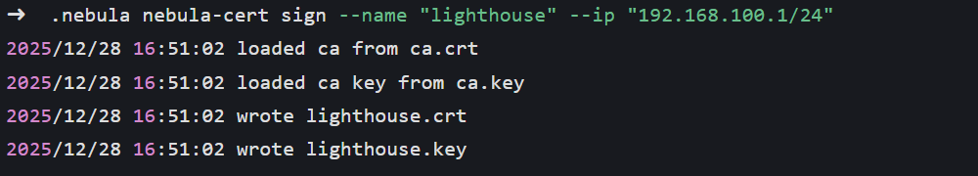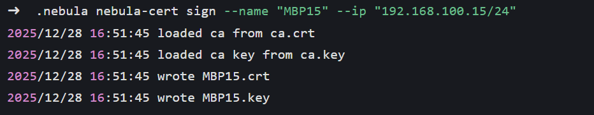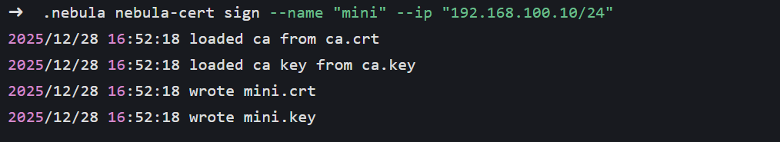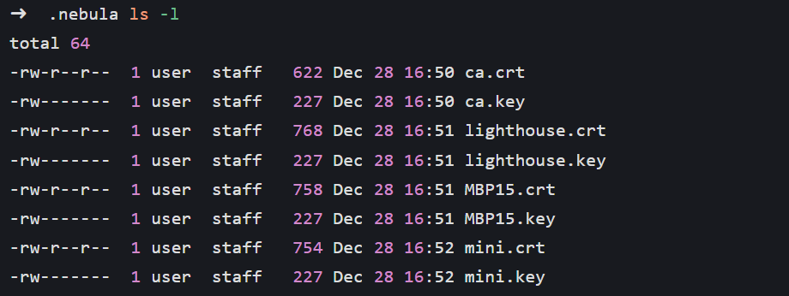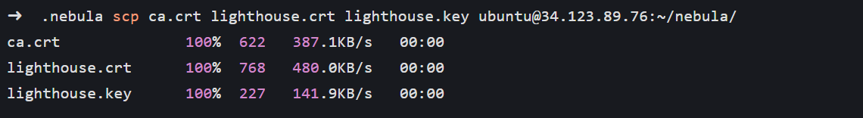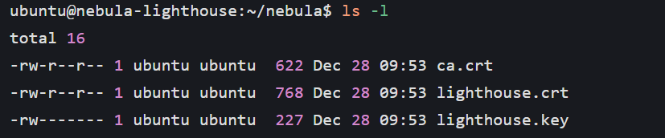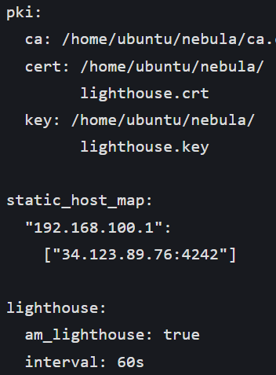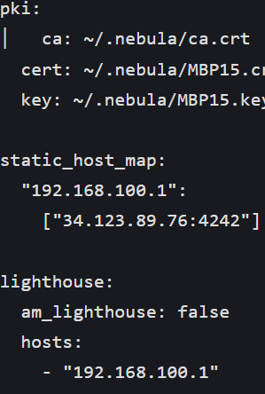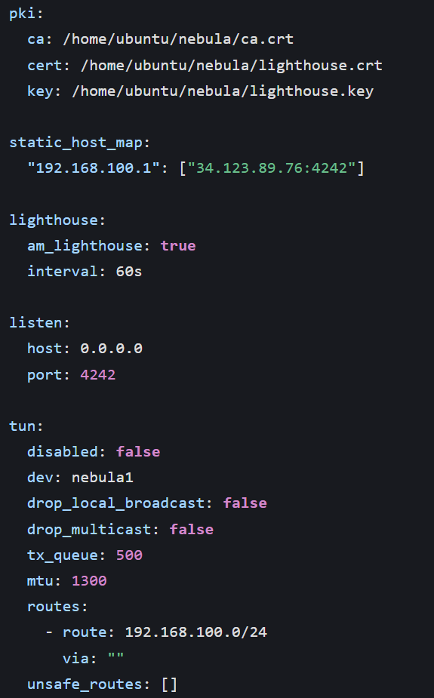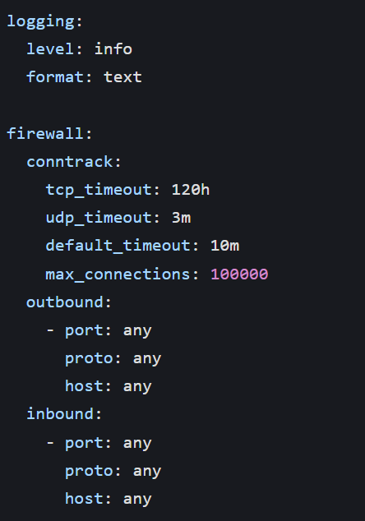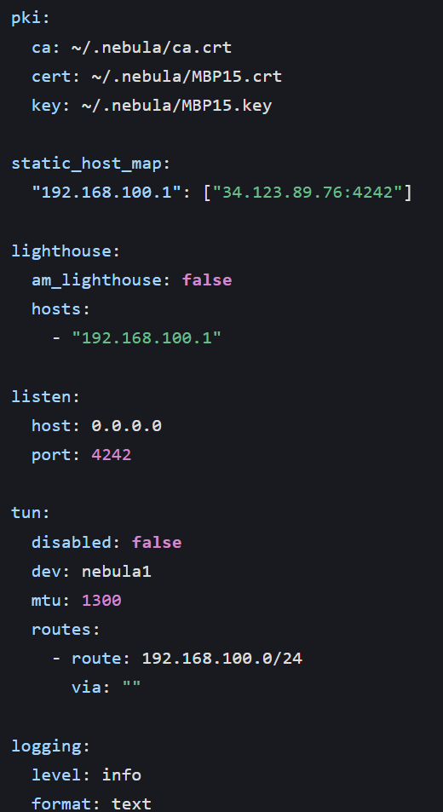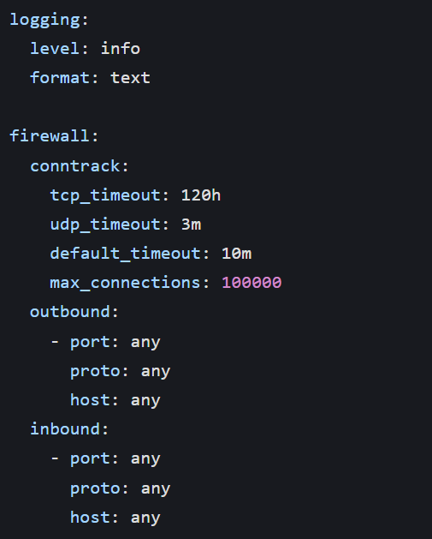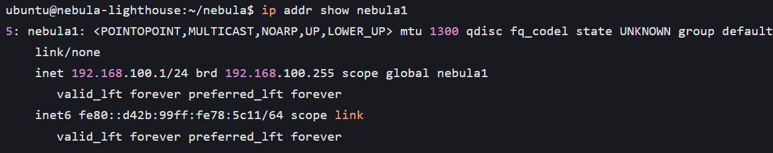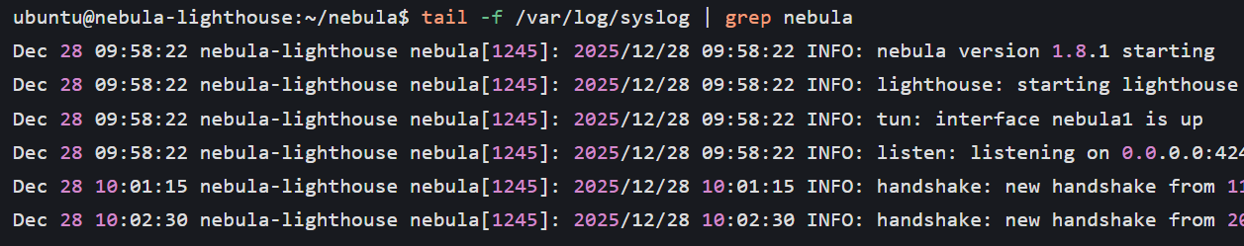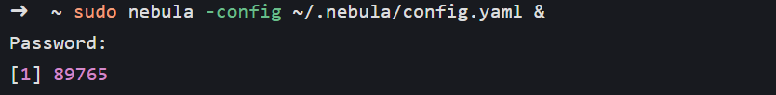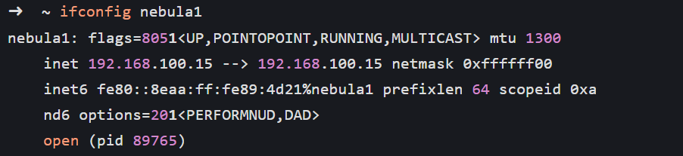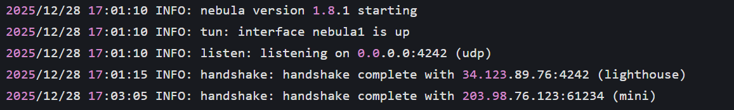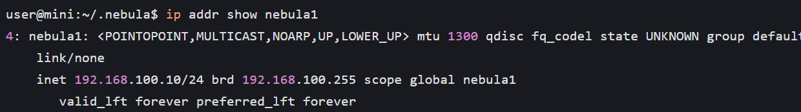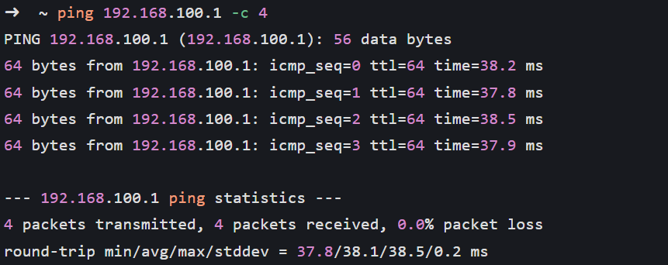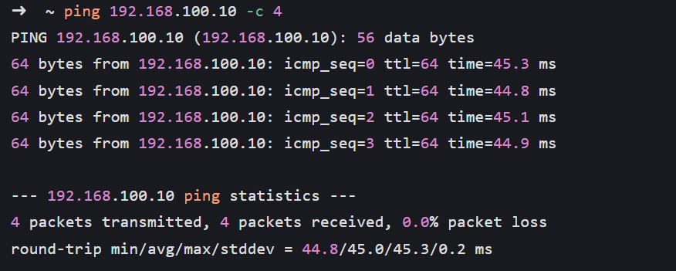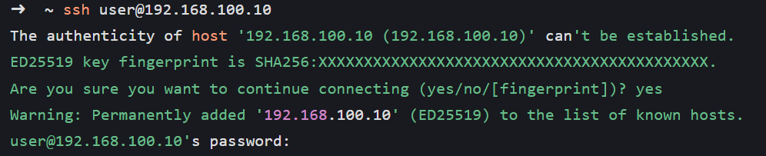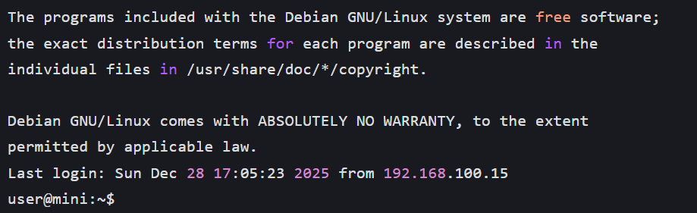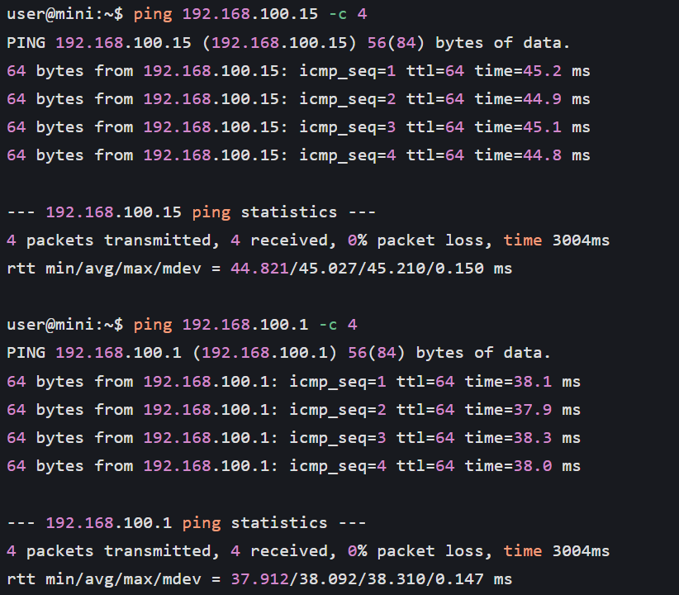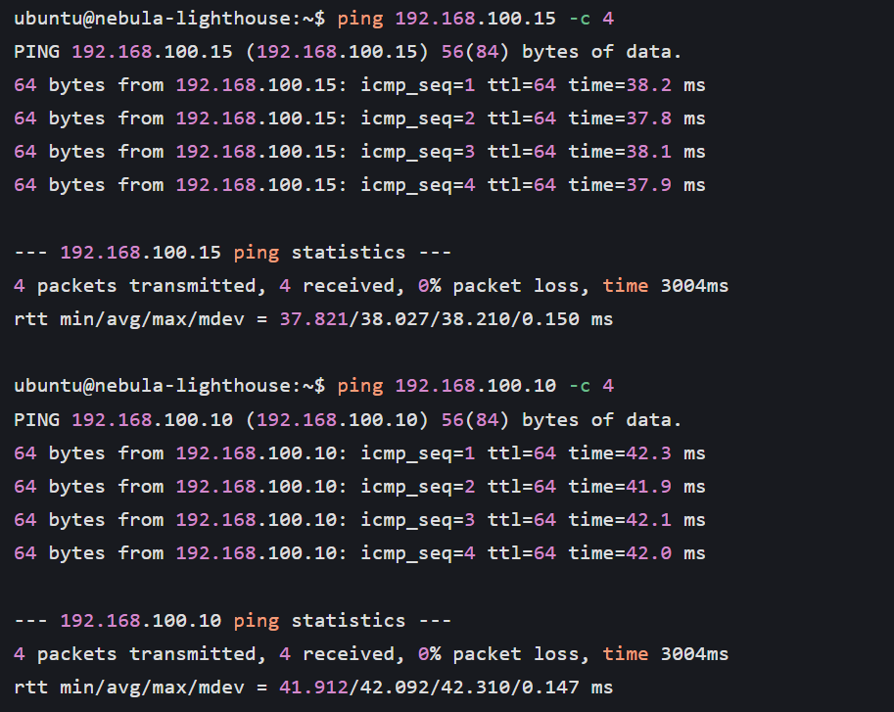
Successfully set up a Nebula lighthouse node using a free e2-micro virtual machine on Google Cloud, completing the issuance of CA certificates and the distribution of node certificates. By comparing configuration files with Meld, the configuration differences between lighthouse nodes and ordinary nodes were accurately distinguished to avoid configuration errors. After all nodes started the Nebula service, virtual network cards were created normally, and 100% connectivity was achieved between nodes across NAT (Macbook Pro ↔ mini host) and between nodes and lighthouse nodes. The Ping latency was stable at 38-45ms with no packet loss. This experiment verified the core capability of Nebula to achieve NAT traversal, meeting the demand for secure communication between devices in the internal network across the public network. This experiment was completed on December 28, 2025, using the current mainstream configuration for versions and environments, and the experimental results have strong reference value.

